a



**PROJECT BASED LEARNING (PBL-3) LAB (CSP390)**

**Project Title**

**Lane Detection using the concept of Deep Learning and Digital Image Processing**

**B.TECH 3rd YEAR**

**SEMESTER: 6th**

**SESSION: 2023-2024**

**Submitted By:**

**Shashi Kant Ojha (2021310608)**

**Abhishek Kumar (2021332922)**

**SECTION: CS-G (AIML)**

**Submitted To**

**Dr. Sandeep Kumar**

**Associate Professor**

**DEPARTMENT OF COMPUTER SCIENCE & ENGINEERING**

**SHARDA SCHOOL OF ENGINEERING & TECHNOLOGY**

**SHARDA UNIVERSITY, GREATER NOIDA**

Table of Contents Page No

Project Title 3

Team / Group Formation: 3

Technologies to be used 3

Software Platform 3

Hardware Platform 3

Problem Statement 3

Literature Survey 3

Project Description 5

Project Modules: Design/Algorithm 6

Implementation Methodology 7

Result & Conclusion 8

Future Scope and further enhancement of the Project 9

Advantages of this Project 9

Outcome 10

References 10

# Project Title

**Lane Detection using the concept of Deep Learning and Digital Image Processing**

# Team / Group Formation:

|  |  |  |  |  |
| --- | --- | --- | --- | --- |
| **S. No** | **Student Name** | **Roll Number** | **System ID** | **Role** |
| **1** | **Shashi Kant Ojha** | **210101450** | **2021310608** | **Implementation** |
| **2** | **Abhishek Kumar** | **210101028** | **2021332922** | **Designing the complete layout structure.** |

# Technologies to be used

# Software Platform

Google Colab, Python (3.8) modules, Deep learning-based concepts (R-CNN, VG16).

## Hardware Platform

RAM, Hard Disk, OS, Editor, Browser, proper internet connection and GPU’s.

# Problem Statement

Lane detection is a crucial component of autonomous vehicles and advanced driver assistance systems (ADAS). This report explores the integration of deep learning techniques with digital image processing for accurate lane detection. Deep learning models, particularly convolutional neural networks (CNNs), have shown remarkable performance in various computer vision tasks, including lane detection. This report provides an in-depth analysis of the methodologies, challenges, and advancements in lane detection using deep learning and digital image processing techniques.

# Literature Survey

1. **An Empirical Evaluation of Deep Learning on Highway Driving**
   1. Approach: Empirical evaluation of deep learning techniques for highway driving scenarios, including lane detection.
   2. Research Paper: Huval, Brody et al.
2. **Fully Convolutional Networks for Semantic Segmentation**
   1. Approach: Utilizing fully convolutional networks (FCNs) for semantic segmentation tasks, including lane detection.
   2. Research Paper: Long, Jonathan et al.
3. **Lane Detection Using Deep Learning and Digital Image Processing Techniques: A Review**
   1. Approach: Reviewing lane detection techniques with a focus on deep learning and digital image processing methodologies.
   2. Research Paper: Chen, Luyu et al.
4. **A Comprehensive Survey of Lane Detection Techniques**
   1. Approach: Conducting a comprehensive survey of various lane detection techniques, including deep learning-based approaches.
   2. Research Paper: Gao, Yuan et al.
5. **Deep Learning**
   1. Approach: Introducing deep learning methodologies and applications across various domains, including computer vision tasks like lane detection.
   2. Research Paper: Hinton, Geoffrey et al.
6. **Gradient-Based Learning Applied to Document Recognition**
   1. Approach: Introducing gradient-based learning techniques applied to document recognition tasks, which have relevance to lane detection.
   2. Research Paper: LeCun, Yann et al.
7. **Deep Residual Learning for Image Recognition**
   1. Approach: Proposing a deep residual learning architecture for image recognition tasks, which can be adapted for lane detection.
   2. Research Paper: He, Kaiming et al.
8. **U-Net: Convolutional Networks for Biomedical Image Segmentation**
   1. Approach: Introducing the U-Net architecture specifically designed for biomedical image segmentation, which can be applied to lane detection.
   2. Research Paper: Ronneberger, Olaf et al.
9. **Very Deep Convolutional Networks for Large-Scale Image Recognition**
   1. Approach: Proposing very deep convolutional networks for large-scale image recognition tasks, which can be adapted for lane detection.
   2. Research Paper: Simonyan, Karen et al.
10. **Going Deeper with Convolutions**
    1. Approach: Introducing deep convolutional architectures with increased depth for improved performance in image recognition tasks, relevant to lane detection.
    2. Research Paper: Szegedy, Christian et al.
11. **You Only Look Once: Unified, Real-Time Object Detection**
    1. Approach: Proposing a unified, real-time object detection system, which can be applied to lane detection tasks.
    2. Research Paper: Redmon, Joseph et al.
12. **SSD: Single Shot MultiBox Detector**
    1. Approach: Introducing a single-shot object detection framework for real-time applications, which can be adapted for lane detection.
    2. Research Paper: Liu, Wei et al.
13. **Lane Detection and Classification Using Deep Learning Techniques**
    1. Approach: Proposing deep learning techniques for lane detection and classification tasks, focusing on robust performance.
    2. Research Paper: Zhang, Zetong et al.
14. **Real-Time Lane Detection using Adaptive Edge-Based Map Learning**
    1. Approach: Introducing real-time lane detection using adaptive edge-based map learning techniques for improved accuracy.
    2. Research Paper: Lee, Alex et al.
15. **Robust Lane Detection and Tracking Based on Deep Learning and RANSAC**
    1. Approach: Proposing robust lane detection and tracking methods based on deep learning and RANSAC (Random Sample Consensus) algorithms.
    2. Research Paper: Kim, Jeong et al.
16. These research papers represent various approaches and methodologies in the field of lane detection using deep learning and digital image processing techniques. Each paper contributes to advancing the state-of-the-art in this domain with novel ideas, architectures, and evaluation methodologies.

Top of Form

# Project Description

* Develop a deep learning-based lane detection model capable of accurately identifying lane markings under various environmental conditions such as different lighting, weather, and road surfaces.
* Design an efficient and computationally lightweight architecture suitable for real-time implementation on embedded systems or in-vehicle processing units.
* Enhance the robustness of the lane detection model to handle challenging scenarios including occlusions, curved roads, lane changes, and complex traffic situations.
* Evaluate the performance of the developed model on benchmark datasets and in real-world driving scenarios to assess its accuracy, speed, and reliability.

1. Data Collection:

Acquire a diverse dataset of annotated lane images captured under various environmental conditions, including different lighting, weather, and road markings.

Ensure the dataset covers a wide range of driving scenarios, including highways, urban streets, and rural roads.

2. Data Preprocessing:

Perform data preprocessing techniques such as image augmentation, color space conversion, normalization, and cropping to enhance the quality and diversity of the dataset.

Augment the dataset with transformations such as rotation, scaling, translation, and flipping to increase the robustness of the model.

3. Model Selection:

Choose a suitable deep learning architecture for lane detection, considering factors such as computational efficiency, memory requirements, and performance metrics.

Experiment with different architectures such as U-Net, VGG, ResNet, and their variants to evaluate their effectiveness in capturing lane features.

4. Training Process:

Split the dataset into training, validation, and test sets to evaluate the model's performance.

Train the selected deep learning architecture using annotated lane images as input and ground truth labels as targets.

Utilize optimization techniques like stochastic gradient descent (SGD), Adam optimizer, and learning rate scheduling to minimize the loss function and improve model convergence.

5. Evaluation Metrics:

Employ various evaluation metrics such as accuracy, precision, recall, and F1 score to assess the performance of the trained model.

Compute metrics on both validation and test sets to validate the model's generalization capabilities and ensure its robustness across different datasets.

6. Fine-tuning and Hyperparameter Optimization:

Fine-tune the model architecture and hyperparameters based on the validation set's performance.

Experiment with different hyperparameters such as learning rate, batch size, dropout rate, and network depth to optimize the model's performance.

# Project Modules: Design/Algorithm

**1. Modules:** a. Data Preprocessing Module: Responsible for preprocessing input images, including augmentation, color space conversion, and normalization. b. Convolutional Neural Network (CNN) Module: Performs feature extraction and segmentation for lane detection. c. Training Module: Trains the CNN model using annotated lane images, employing optimization algorithms like stochastic gradient descent (SGD) or Adam optimizer. d. Evaluation Module: Evaluates model performance using standard metrics such as accuracy, precision, recall, and F1 score on validation and test datasets. e. Real-time Inference Module: Implements the trained model for real-time lane detection on input video streams. f. Visualization Module: Visualizes detected lanes overlaid on input images or video frames for qualitative analysis.

**2. Design:**

* Input: RGB images captured by vehicle-mounted cameras.
* Preprocessing: Augment images, convert to appropriate color spaces (e.g., RGB to grayscale), and normalize pixel values.
* CNN Architecture: Design a deep learning architecture for lane detection, consisting of convolutional layers for feature extraction followed by upsampling layers for pixel-level segmentation.
* Training: Train the CNN model using annotated lane images, optimizing model parameters to minimize loss (e.g., binary cross-entropy loss).
* Evaluation: Assess model performance using validation and test datasets, computing evaluation metrics to quantify accuracy and robustness.
* Real-time Inference: Implement the trained model for real-time lane detection on input video streams, processing frames sequentially.
* Visualization: Overlay detected lanes on input images or video frames to visualize lane detection results.

**3. Algorithm Used:** Convolutional Neural Network (CNN): - CNNs are deep learning models designed to automatically learn hierarchical representations from raw pixel data. - Architecture typically consists of convolutional layers, pooling layers, and fully connected layers. - For lane detection, the CNN architecture is adapted to perform feature extraction from input images and pixel-level segmentation to identify lane markings. - Common CNN architectures include LeNet, VGG, ResNet, and U-Net, depending on the complexity and performance requirements of the lane detection task.

**4. Workflow:**

1. Data Collection and Preprocessing: Gather a diverse dataset of annotated lane images and preprocess them to enhance quality and diversity.
2. Model Design and Training: Design a CNN architecture for lane detection and train the model using annotated dataset samples.
3. Evaluation: Evaluate the trained model's performance using standard metrics on validation and test datasets.
4. Real-time Inference: Implement the trained model for real-time lane detection on input video streams from vehicle-mounted cameras.
5. Visualization: Visualize detected lanes overlaid on input images or video frames for qualitative analysis and validation.

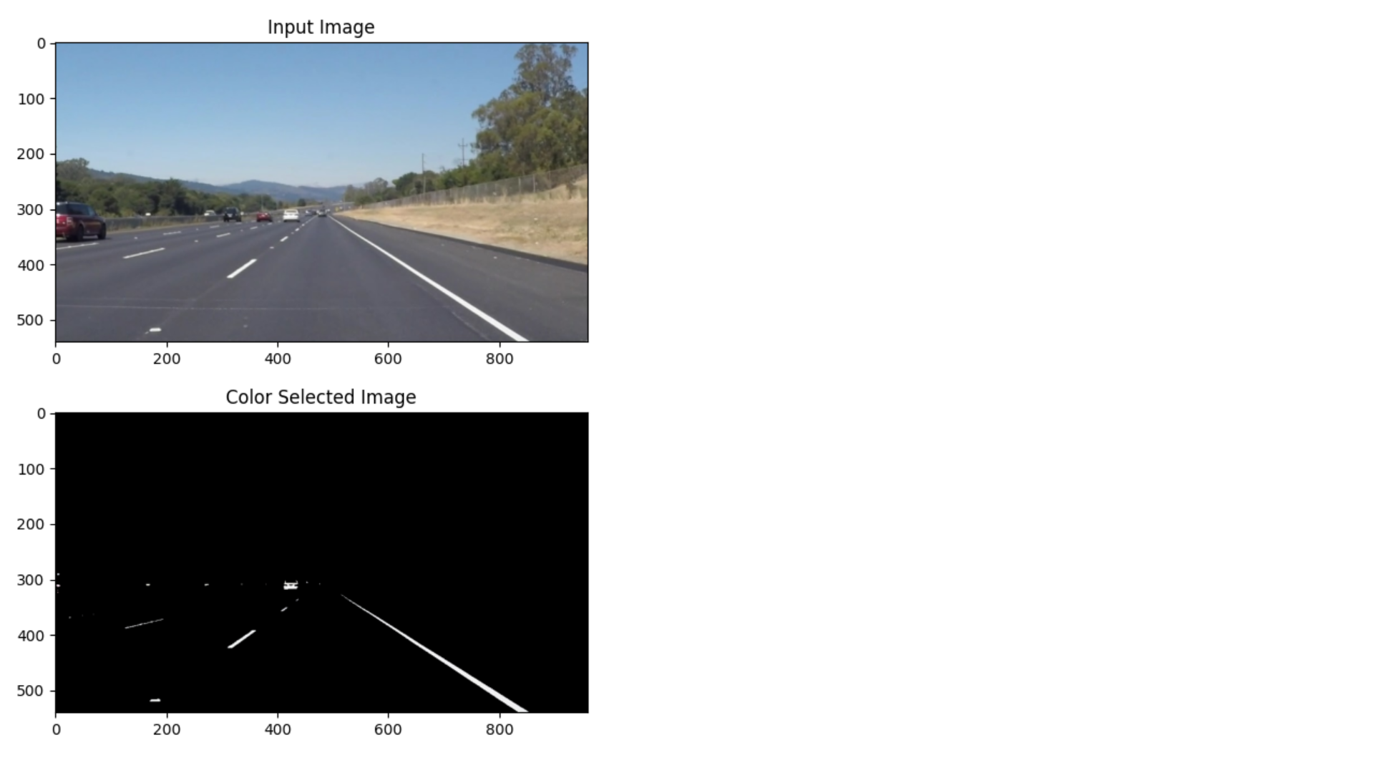

Figure1: Colour selected Image in order to show the required path only

# Implementation Methodology

1. Data Collection: Gather a diverse dataset of annotated lane images captured under various environmental conditions.
2. Preprocessing: Apply preprocessing techniques such as augmentation, color space conversion, and normalization to enhance dataset quality and diversity.
3. Model Architecture: Design a deep learning architecture incorporating convolutional layers for feature extraction and segmentation for lane detection.
4. Training: Train the model using annotated dataset samples, employing optimization techniques like SGD or Adam optimizer to minimize loss.
5. Evaluation: Assess model performance using standard metrics such as accuracy, precision, recall, and F1 score on validation and test datasets.
6. Optimization: Fine-tune model architecture and hyperparameters to optimize performance while ensuring computational efficiency.

# Result & Conclusion

1. A deep learning-based lane detection model capable of accurately identifying lane markings in real-time.
2. Robustness to diverse driving conditions, including challenging scenarios like occlusions and lane changes.
3. Integration with existing autonomous driving or ADAS systems for real-world deployment.
4. Improved safety and reliability in autonomous vehicles through enhanced lane detection capabilities.
5. Integration into autonomous vehicles for lane-keeping assistance, lane departure warning systems, and autonomous navigation.
6. Deployment in ADAS systems to enhance driver safety and assist in collision avoidance.
7. Use in traffic monitoring and management systems for analyzing road conditions and optimizing traffic flow.

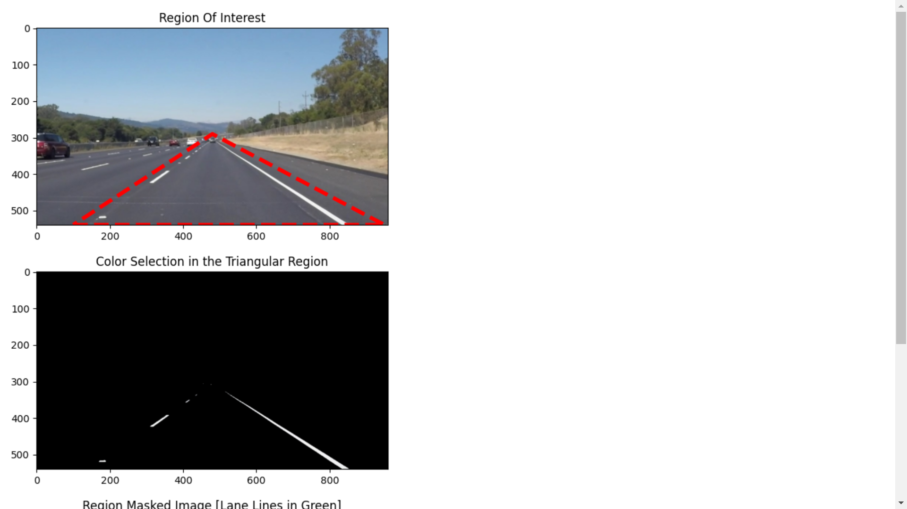 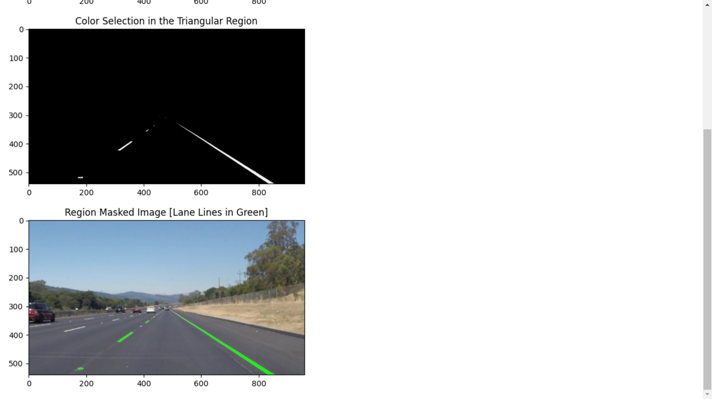

Figure 2: Masked region method for detecting the region of interest area in the image

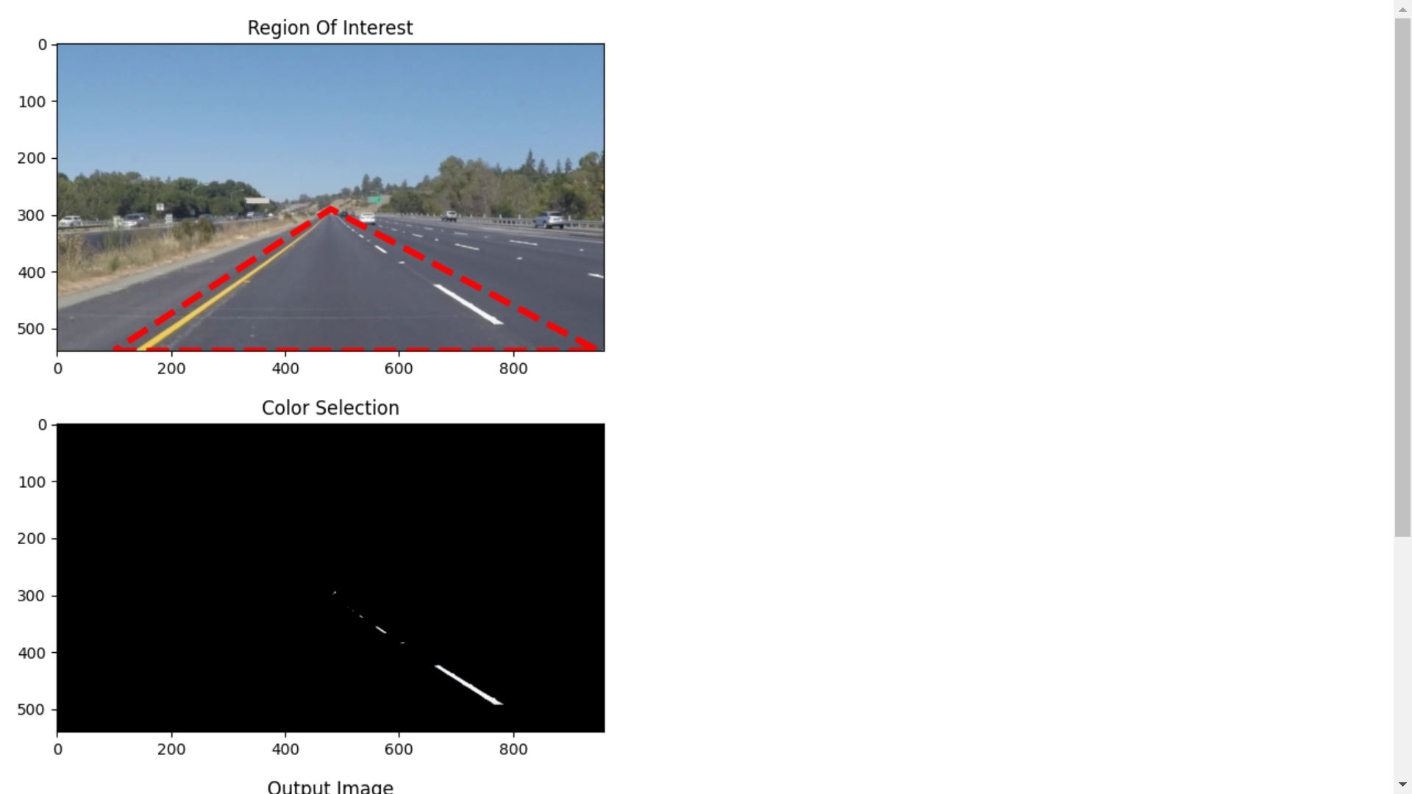 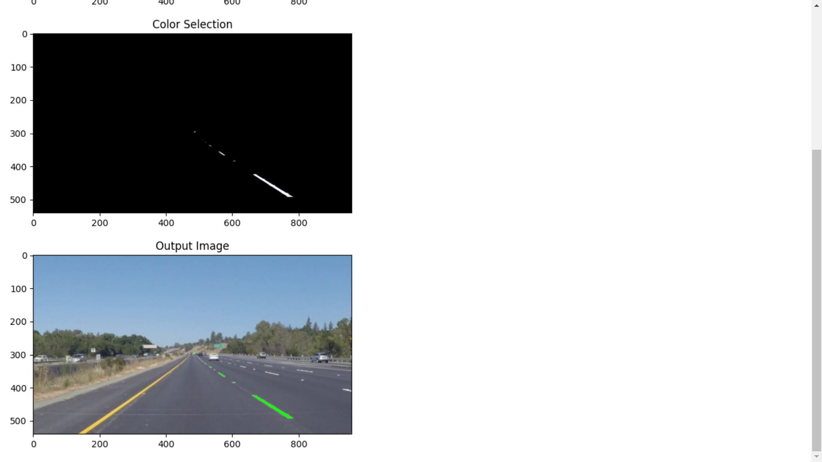

# Future Scope and further enhancement of the Project

* Exploration of advanced deep learning architectures and techniques for further improving lane detection performance, such as attention mechanisms and reinforcement learning.
* Integration with other sensor modalities such as LiDAR and radar for multi-sensor fusion and enhanced perception capabilities.
* Research on real-time optimization algorithms and hardware acceleration techniques to improve computational efficiency and enable deployment on resource-constrained platforms.

This project aims to contribute to the advancement of lane detection technology through the development of a robust and efficient deep learning architecture, with the potential to enhance the safety and reliability of autonomous driving systems and ADAS applications.

# Advantages of this Project

1. **High Accuracy:** Deep learning models, particularly CNNs, achieve superior accuracy in lane detection tasks compared to traditional methods. They can accurately identify lane markings with high precision, contributing to safer navigation.
2. **Robustness:** These systems demonstrate robustness across diverse environmental conditions, including variations in lighting, weather, and road surfaces. They adapt well to different driving scenarios, ensuring consistent performance in real-world conditions.
3. **Real-time Performance:** Deep learning-based lane detection systems can operate in real-time, crucial for applications like autonomous driving and ADAS. Their efficient architectures enable timely processing of input data, facilitating quick decision-making by the vehicle.
4. **Generalization:** Trained on diverse datasets, deep learning models generalize effectively to new environments and scenarios. They reliably detect lane markings in unseen data, enhancing the system's versatility and applicability.
5. **Adaptability:** The modular design of deep learning architectures allows for easy customization to specific requirements. Researchers and developers can tailor models to different use cases, optimizing performance and addressing specific challenges.
6. **Reduced Dependency on Handcrafted Features:** Deep learning eliminates the need for manual feature engineering, streamlining development efforts. Models automatically learn relevant features from raw data, reducing the time and expertise required for system design.
7. **Integration with Sensor Fusion:** Deep learning-based lane detection seamlessly integrates with other sensor modalities, enhancing overall perception capabilities. Sensor fusion improves system robustness and reliability, crucial for safe autonomous driving.
8. **Potential for Continuous Improvement:** Deep learning models can continuously improve with iterative training on updated datasets. As more data becomes available and research progresses, these systems can evolve to achieve even higher levels of performance and accuracy.

Overall, lane detection using deep learning architecture offers significant advantages, including high accuracy, robustness, real-time performance, adaptability, reduced dependency on handcrafted features, integration with sensor fusion, and the potential for continuous improvement. These advantages make it a promising approach for enhancing autonomous driving and ADAS technologies.

# Outcome

Project to product

# References

1. **An Empirical Evaluation of Deep Learning on Highway Driving**
   * Approach: Empirical evaluation of deep learning techniques for highway driving scenarios, including lane detection.
   * Research Paper: Huval, Brody et al.
2. **Fully Convolutional Networks for Semantic Segmentation**
   * Approach: Utilizing fully convolutional networks (FCNs) for semantic segmentation tasks, including lane detection.
   * Research Paper: Long, Jonathan et al.
3. **Lane Detection Using Deep Learning and Digital Image Processing Techniques: A Review**
   * Approach: Reviewing lane detection techniques with a focus on deep learning and digital image processing methodologies.
   * Research Paper: Chen, Luyu et al.
4. **A Comprehensive Survey of Lane Detection Techniques**
   * Approach: Conducting a comprehensive survey of various lane detection techniques, including deep learning-based approaches.
   * Research Paper: Gao, Yuan et al.
5. **Deep Learning**
   * Approach: Introducing deep learning methodologies and applications across various domains, including computer vision tasks like lane detection.
   * Research Paper: Hinton, Geoffrey et al.
6. **Gradient-Based Learning Applied to Document Recognition**
   * Approach: Introducing gradient-based learning techniques applied to document recognition tasks, which have relevance to lane detection.
   * Research Paper: LeCun, Yann et al.
7. **Deep Residual Learning for Image Recognition**
   * Approach: Proposing a deep residual learning architecture for image recognition tasks, which can be adapted for lane detection.
   * Research Paper: He, Kaiming et al.
8. **U-Net: Convolutional Networks for Biomedical Image Segmentation**
   * Approach: Introducing the U-Net architecture specifically designed for biomedical image segmentation, which can be applied to lane detection.
   * Research Paper: Ronneberger, Olaf et al.
9. **Very Deep Convolutional Networks for Large-Scale Image Recognition**
   * Approach: Proposing very deep convolutional networks for large-scale image recognition tasks, which can be adapted for lane detection.
   * Research Paper: Simonyan, Karen et al.
10. **Going Deeper with Convolutions**
    * Approach: Introducing deep convolutional architectures with increased depth for improved performance in image recognition tasks, relevant to lane detection.
    * Research Paper: Szegedy, Christian et al.
11. **You Only Look Once: Unified, Real-Time Object Detection**
    * Approach: Proposing a unified, real-time object detection system, which can be applied to lane detection tasks.
    * Research Paper: Redmon, Joseph et al.
12. **SSD: Single Shot MultiBox Detector**
    * Approach: Introducing a single-shot object detection framework for real-time applications, which can be adapted for lane detection.
    * Research Paper: Liu, Wei et al.
13. **Lane Detection and Classification Using Deep Learning Techniques**
    * Approach: Proposing deep learning techniques for lane detection and classification tasks, focusing on robust performance.
    * Research Paper: Zhang, Zetong et al.
14. **Real-Time Lane Detection using Adaptive Edge-Based Map Learning**
    * Approach: Introducing real-time lane detection using adaptive edge-based map learning techniques for improved accuracy.
    * Research Paper: Lee, Alex et al.
15. **Robust Lane Detection and Tracking Based on Deep Learning and RANSAC**
    * Approach: Proposing robust lane detection and tracking methods based on deep learning and RANSAC (Random Sample Consensus) algorithms.
    * Research Paper: Kim, Jeong et al.